# Multiple-choice answers and questions

Fall 2020

Tram Lai

1. **Description**

People usually see math as a boring and dull subject, so I decide to make a game that help people practice with numbers and improve their mathematical skills by finding the correct answer. The game acts like a private practice where a player can play game with multiple choice answers’ buttons and gain scores. The database tables are the place to store player’s information and score.

* Player level: login, sign up, change player’s profile, unsubscribe, play, suggest a question, accuracy, list ranking, share game, view player’s past score, and exit.
* Player game: display timer, score, equation and three answers as buttons.

There will be one correct answer’s button and player must click on the correct answer to gain score and continue the game.

After clicking on the correct answer’s button, the game will generate a new equation, answers’ buttons, timer and add score. If player clicks on the wrong answer’s button, the equation and the buttons remain the same, but the timer continues countdown, player loses score for each wrong click button. When player can not find the correct answer and time out, the game will stop and pass the username and the score to the database.

1. **List of detail user level, not programming level, features with descriptions**

User-level features are like the actions that the users can take.

* They should be **testable**. They will be tested when your app is evaluated.

|  |  |
| --- | --- |
| Feature | Description |
| Sign up | Allow player to signup |
| Login | Allow player to log in |
| Change a player’s profile | Allow player to change their information |
| Unsubscribe | Allow player to delete their account |
| Play | Allow user to play the game |
| Suggest a question | Player can submit a question and an answer so other players can play the question later |
| List ranking | Display the average scores of all players |
| Share game | Allow player to send the game’s link through email |
| View player’s past scores | Allow player to view their past scores |
| Accuracy | Allow player to see the percentage accuracy when the game ends.  The percentage is calculated based on the correct answer(s) in the first click, not the second/third click  % = ( total correct answer(s)/total generated equation) *100 |
| Exit (Sign Out) | Allow user to exit the game, return to the login page |

1. **Page layout diagrams and user interface**

Start page:

Username:

LOGIN

SIGNUP

Password:

Main page:

Change Profile/ Unsubscribe

Play

View your past scores

Share game

List ranking

Suggest a question

play page:

Score

Exit

timer

Equation

Answer3

Answer2

Answer1

Change profile/unsubscribe page (ajax):

Email input

Unsubscribe

Username input

Password input

submit

Share game page:

twitter

facebook

View your scores/ list ranking page (ajax):

List ranking/ your Scores

Scores display

Suggest a question:

Question

Answer

Submit

Database table:

Player’s table:

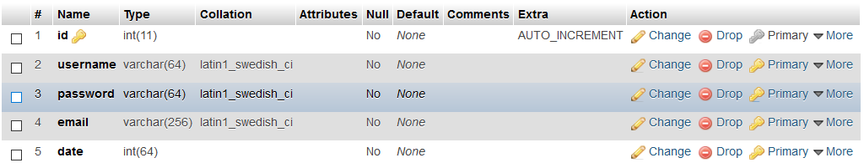

Score’s table:

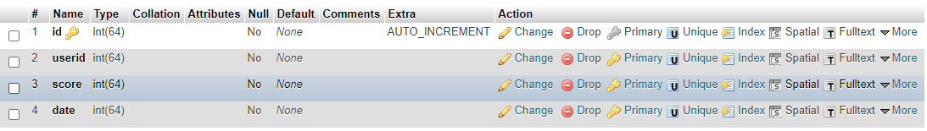

SuggestedQuestion’s table:

